# Recipes

You need to add 17 things to this document. (Make sure to number them just as I did in the example.) It may be helpful to copy and paste this list and then fill it in as you go along. All image names must start with your location, e.g yellowstone_sunset.jpg unless you are using a link from the internet.

## Chinese Jiaozi

1. **Origin**: China
2. **Source**: flour, pork and cabbage
3. **Category**: Main Dish
4. 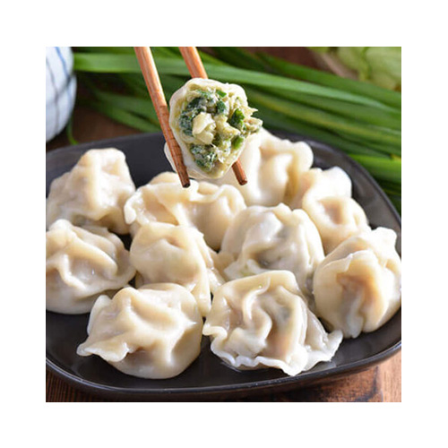
5. jiaozi.jpeg
6. Chinese dumplings (Jiaozi, 饺子) are stuffed parcels made of unleavened dough and savoury fillings consisting of minced ingredients like meat, egg, tofu, or vegetables. They can be boiled, pan-fried or steamed.
7. **Recipe Ingredients – Just write Recipe Ingredients**
   1. flour
   2. water
   3. pork
   4. cabbage
8. **Recipe Steps – Just write Recipe Steps**
   1. Dough
   2. Filling
   3. Folding
   4. Cooking
   5. dipping sauces
9. 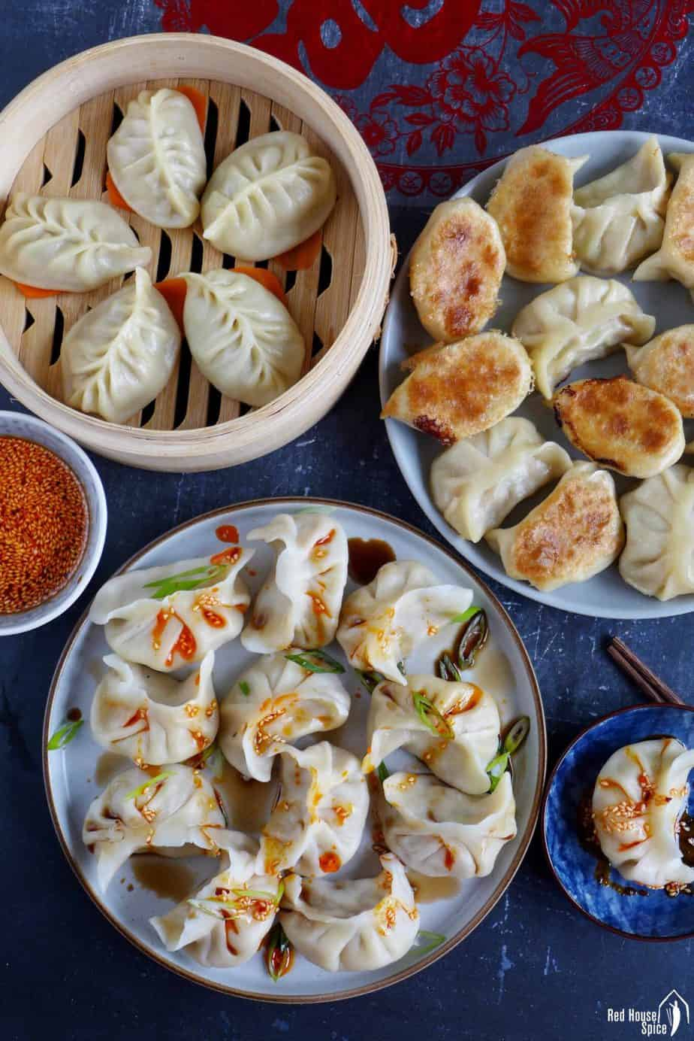
10. jiaozi2.jpeg
11. Three dishes of Jiaozi.
12. 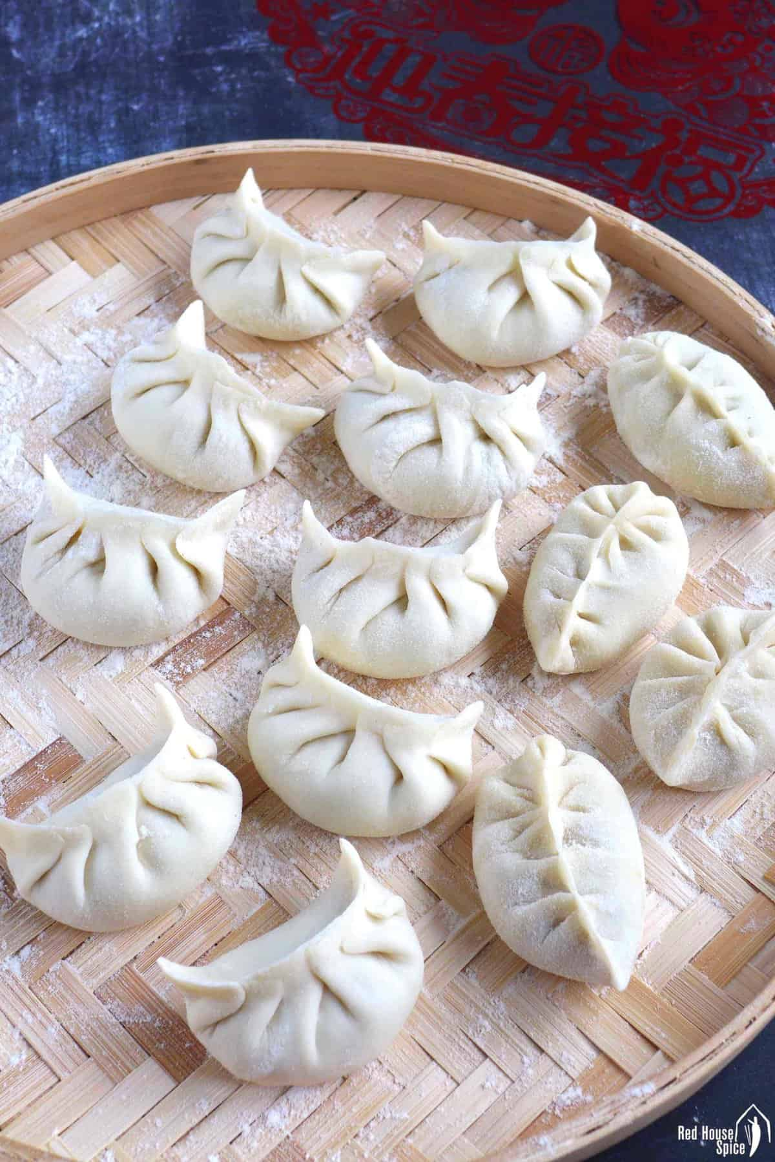
13. Jiaozi3.jpegs
14. Steamed jiaozi
15. 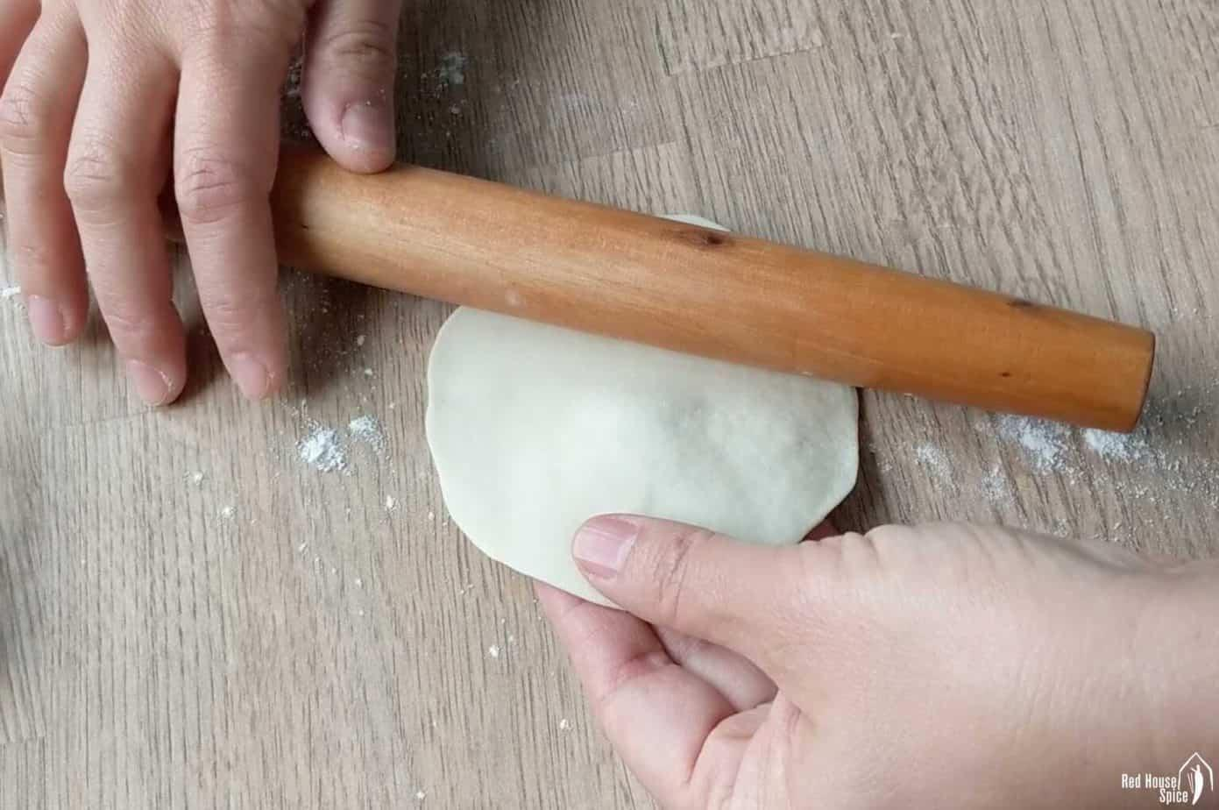
16. jiaozi4.jpeg
17. Making jiaozi
18. Meiqi Zhao